Ex2.1

Class Author:

**public** **class** Author {

**private** String name;

**private** String email;

**private** **char** gender;

**public** Author(String name, String email, **char** gender) {

**this**.name = name;

**this**.email = email;

**this**.gender = gender;

}

**public** String getName() {

**return** name;

}

**public** **char** getGender() {

**return** gender;

}

**public** String getEmail() {

**return** email;

}

**public** **void** setEmail(String email) {

**this**.email = email;

}

**public** String toString() {

**return** name + " (" + gender + ") at " + email;

}

}

Book composes Author:

**public** **class** Book {

**private** String name;

**private** Author author;

**private** **double** price;

**private** **int** qty;

**public** Book(String name, Author author, **double** price, **int** qty) {

**this**.name = name;

**this**.author = author;

**this**.price = price;

**this**.qty = qty;

}

**public** Book(String name, Author author, **double** price) {

**this**.name = name;

**this**.author = author;

**this**.price = price;

}

**public** String getName() {

**return** name;

}

**public** Author getAuthor() {

**return** author;

}

**public** String getAuthorName(){

**return** author.getName();

}

**public** **char** getAuthorGender(){

**return** author.getGender();

}

**public** String getAuthorEmail(){

**return** author.getEmail();

}

**public** **double** getPrice() {

**return** price;

}

**public** **void** setPrice(**double** price) {

**this**.price = price;

}

**public** **int** getQty() {

**return** qty;

}

**public** **void** setQty(**int** qty) {

**this**.qty = qty;

}

**public** String toString() {

**return** "'" + name + "' by " + author;

}

}

TestBook tests Book:

**public** **class** TestBook {

**public** **static** **void** main(String[] args) {

Author ahTeck = **new** Author("Tan Ah Teck", "ahTeck@somewhere.com", 'm');

System.***out***.println(ahTeck);

Book dummyBook = **new** Book("Java for dummies", ahTeck, 9.99, 99);

System.***out***.println(dummyBook);

dummyBook.setPrice(8.88);

dummyBook.setQty(88);

System.***out***.println(dummyBook);

System.***out***.println("name is: " + dummyBook.getName());

System.***out***.println("price is: " + dummyBook.getPrice());

System.***out***.println("qty is: " + dummyBook.getQty());

System.***out***.println("author is: " + dummyBook.getAuthor());

System.***out***.println("author's name is: " + dummyBook.getAuthor().getName());

System.***out***.println("author's email is: " + dummyBook.getAuthor().getEmail());

System.***out***.println("author's gender is: " + dummyBook.getAuthor().getGender());

Book moreDummyBook = **new** Book("Java for more dummies",

**new** Author("Peter Lee", "peter@nowhere.com", 'm'),

19.99, 8);

System.***out***.println(moreDummyBook);

}

}

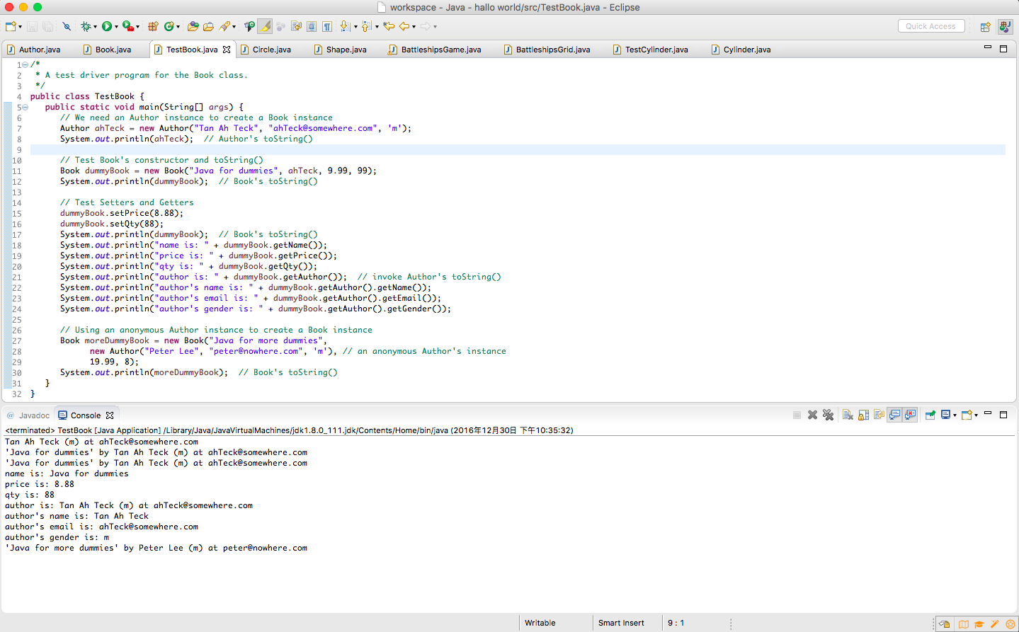

Ex 4.1

Class Shape:

**public** **class** Shape {

**private** String color;

**private** **boolean** filled;

**public** Shape(){

color = "red";

filled = **true**;

}

**public** Shape(String color,**boolean** filled){

**this**.color = color;

**this**.filled = filled;

}

**public** String getColor(){

**return** color;

}

**public** **boolean** isFilled(){

**return** filled;

}

**public** **void** setcolor(String color){

**this**.color = color;

}

**public** **void** setFilled(**boolean** filled){

**this**.filled = filled;

}

**public** String toString(){

**if** (filled==**true**){

**return** "A Shape with color of "+color+" and filled.";

}

**else**{

**return** "A Shape with color of "+color+" and Not filled.";

}

}

}

class Circle extends Shape:

**public** **class** Circle **extends** Shape {

**private** **double** radius;

**public** Circle(){

**super**();

radius = 1.0;

}

**public** Circle(**double** radius){

**super**();

**this**.radius = radius;

}

**public** Circle(**double** radius,String color,**boolean** filled){

**super**(color,filled);

**this**.radius = radius;

}

**public** **double** getRadius(){

**return** radius;

}

**public** **void** setRadius(**double** radius){

**this**.radius = radius;

}

**public** **double** getArea(){

**return** Math.***PI***\*radius*radius;

}

**public** **double** getPerimeter(){

**return** Math.***PI***\*radius*2;

}

**public** String toString(){

**return** "A Circle with radius="+radius+" , which is a subclass of "+**super**.toString();

}

}

class Cylinder extends Circle:

**public** **class** Cylinder **extends** Circle {

**private** **double** height;

**public** Cylinder() {

**super**();

height = 1.0;

}

**public** Cylinder(**double** height) {

**super**();

**this**.height = height;

}

**public** Cylinder(**double** radius, **double** height) {

**super**(radius);

**this**.height = height;

}

**public** **double** getHeight() {

**return** height;

}

**public** **double** getVolume() {

**return** **super**.getArea()*height;

}

**public** **double** getArea(){

**return** **super**.getArea()*2+getPerimeter()*height;

}

**public** String toString() {

**return** "Cylinder: subclass of "+**super**.toString()+ " height=" + height;

}

}

TestCylinder tests Cylinder:

**public** **class** TestCylinder {

**public** **static** **void** main (String[] args) {

Cylinder c1 = **new** Cylinder();

System.***out***.println("Cylinder:"

+ " radius=" + c1.getRadius()

+ " height=" + c1.getHeight()

+ " base area=" + c1.getArea()

+ " volume=" + c1.getVolume());

Cylinder c2 = **new** Cylinder(10.0);

System.***out***.println("Cylinder:"

+ " radius=" + c2.getRadius()

+ " height=" + c2.getHeight()

+ " base area=" + c2.getArea()

+ " volume=" + c2.getVolume());

Cylinder c3 = **new** Cylinder(2.0, 10.0);

System.***out***.println("Cylinder:"

+ " radius=" + c3.getRadius()

+ " height=" + c3.getHeight()

+ " base area=" + c3.getArea()

+ " volume=" + c3.getVolume());

}

}

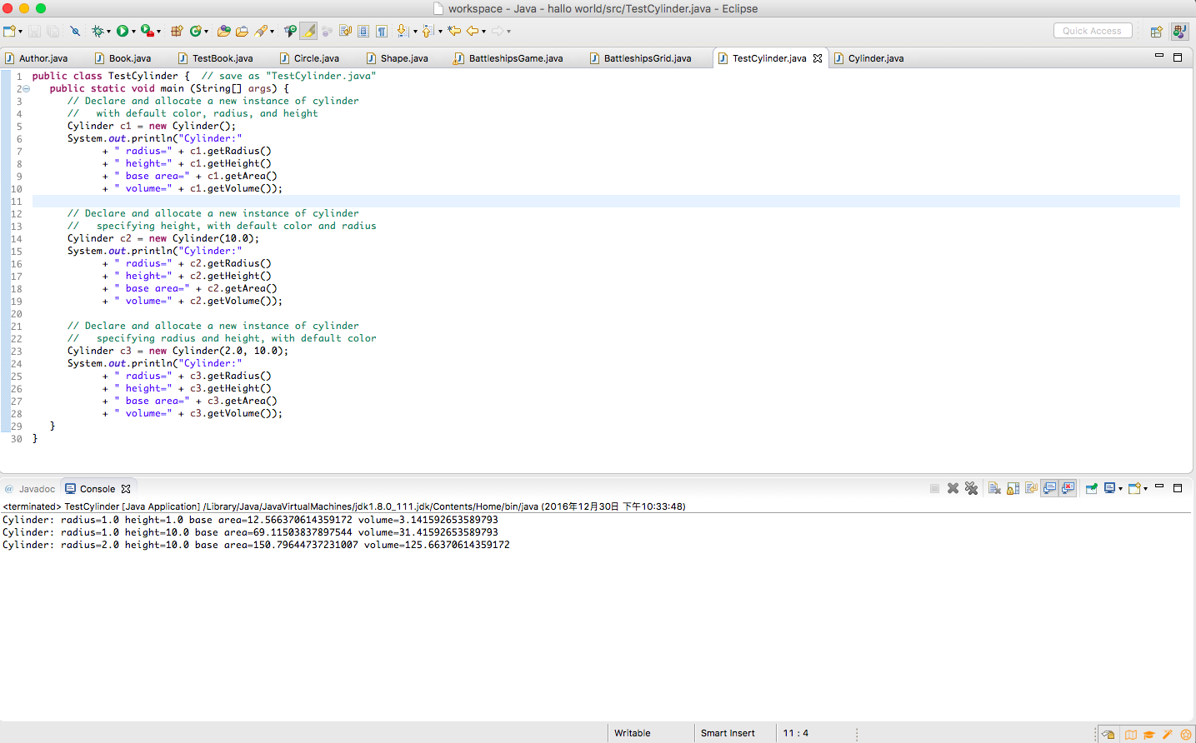

Ex 4.3

Class Point2D:

**package** program;

**public** **class** Point2D {

**private** **double** x = 0.0f;

**private** **double** y = 0.0f;

**public** Point2D(**double** x,**double** y){

**this**.x = x;

**this**.y = y;

}

**public** Point2D(){

}

**public** **double** getX(){

**return** x;

}

**public** **double** getY(){

**return** y;

}

**public** **void** setX(**double** x){

**this**.x = x;

}

**public** **void** setY(**double** y){

**this**.y = y;

}

**public** **void** setXY(**double** x,**double** y){

**this**.x = x;

**this**.y = y;

}

**public** **double**[] getXY(){

**double**[] result = {x,y};

**return** result;

}

**public** String toString(){

**return** "("+x+" , "+y+")";

}

}

class Point3D extends Point2D:

**package** program;

**public** **class** Point3D **extends** Point2D{

**private** **double** z = 0.0f;

**public** Point3D(**double** x, **double** y,**double** z){

**super**(x,y);

**this**.z = z;

}

**public** Point3D(){

**super**();

}

**public** **double** getZ(){

**return** z;

}

**public** **void** setXYZ(**double** x, **double** y,**double** z){

setXY(x,y);

**this**.z = z;

}

**public** **double**[] getXYZ(){

**double**[] result = {getX(),getY(),z};

**return** result;

}

**public** String toString(){

**return** "("+getX()+" , "+getY()+","+z+")";

}

}

TestPoint tests Point3D

**package** program;

**public** **class** TestPoint {

**public** **static** **void** main(String[] args) {

Point3D p1 = **new** Point3D();

Point3D p2 = **new** Point3D(1.1,2.2,3.3);

System.***out***.println(p1);

System.***out***.println(p2);

p2.setXYZ(1.0,2.0,3.0);

System.***out***.println(p2);

}

}

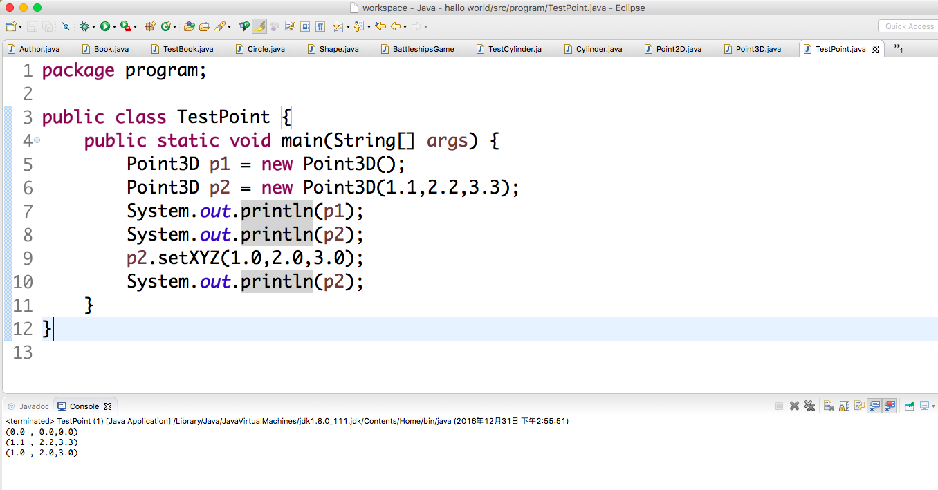

Ex 4.4

Class Point:

**package** program;

**public** **class** Point {

**private** **double** x = 0.0f;

**private** **double** y = 0.0f;

**public** Point() {

**this**.x = 0.0;

**this**.y = 0.0;

}

**public** Point(**double** x, **double** y) {

**this**.x = x;

**this**.y = y;

}

**public** **double** getX() {

**return** **this**.x;

}

**public** **void** setX(**double** x) {

**this**.x = x;

}

**public** **double** getY() {

**return** **this**.y;

}

**public** **void** setY(**double** y) {

**this**.y = y;

}

**public** String toString() {

**return** "(" + **this**.x + "," + **this**.y + ")";

}

**public** **double**[] getXY() {

**double**[] results = **new** **double**[2];

results[0] = **this**.x;

results[1] = **this**.y;

**return** results;

}

**public** **void** setXY(**double** x, **double** y) {

**this**.x = x;

**this**.y = y;

}

}

Class MovablePoint extends Point:

**package** program;

**public** **class** MovablePoint **extends** Point{

**private** **double** xSpeed = 0.0f;

**private** **double** ySpeed = 0.0f;

**public** MovablePoint(**double** xSpeed, **double** ySpeed){

**super**();

**this**.xSpeed = xSpeed;

**this**.ySpeed = ySpeed;

}

**public** MovablePoint(**double** x, **double** y, **double** xSpeed, **double** ySpeed){

**super**(x,y);

**this**.xSpeed = xSpeed;

**this**.ySpeed = ySpeed;

}

**public** MovablePoint(){

**super**();

**this**.xSpeed = 0.0;

**this**.ySpeed = 0.0;

}

**public** **double** getXSpeed(){

**return** xSpeed;

}

**public** **double** getYSpeed(){

**return** ySpeed;

}

**public** **void** setXSpeed(**double** xSpeed){

**this**.xSpeed = xSpeed;

}

**public** **void** setYSpeed(**double** ySpeed){

**this**.ySpeed = ySpeed;

}

**public** **void** setSpeed(**double** xSpeed, **double** ySpeed){

**this**.xSpeed = xSpeed;

**this**.ySpeed = ySpeed;

}

**public** **double**[] getSpeed(){

**double**[] result = {xSpeed,ySpeed};

**return** result;

}

**public** String toString(){

**return** **super**.toString()+" , "+"speed = ("+xSpeed+" , "+ySpeed+")";

}

**public** MovablePoint move(){

setX(getX()+xSpeed);

setY(getY()+ySpeed);

**return** **this**;

}

}

TestMovablePoint tests MavablePoint:

**package** program;

**public** **class** TestMovablePoint {

**public** **static** **void** main(String[] args) {

MovablePoint p1= **new** MovablePoint();

MovablePoint p2= **new** MovablePoint(1.1,2.2,3.3,4.4);

MovablePoint p3= **new** MovablePoint(5.5,6.6);

System.***out***.println(p1);

System.***out***.println(p2);

System.***out***.println(p3);

p2.move();

System.***out***.println(p2);

p2.setSpeed(10, 10);

p2.move();

System.***out***.println(p2);

}

}

